SCHOOL OF COMPUTER SCIENCE AND ARTIFICIAL INTELLIGENCE |  |  |  |  | DEPARTMENT OF COMPUTER SCIENCE ENGINEERING
Program Name: B. Tech |  |  |  | Assignment Type: Lab |  |  | Academic Year:2025-2026
Course Coordinator Name |  |  |  | Dr. Rishabh Mittal
Instructor(s) Name |  |  |  | Mr. S Naresh Kumar  Ms. B. Swathi  Dr. Sasanko Shekhar Gantayat  Mr. Md Sallauddin  Dr. Mathivanan  Mr. Y Srikanth  Ms. N Shilpa  Dr. Rishabh Mittal (Coordinator)  Dr. R. Prashant Kumar  Mr. Ankushavali MD  Mr. B Viswanath  Ms. Sujitha Reddy  Ms. A. Anitha  Ms. M.Madhuri  Ms. Katherashala Swetha  Ms. Velpula sumalatha  Mr. Bingi Raju
CourseCode |  |  | 23CS002PC304 | Course Title |  | AI Assisted Coding
Year/Sem |  |  | III/II | Regulation |  | R23
Date and Day  of Assignment |  |  | Week10 – Monday | Time(s) |  | 23CSBTB01 To 23CSBTB52
Duration |  |  | 2 Hours | Applicable to  Batches |  | All batches
Assignment Number:20.1(Present assignment number)/24(Total number of assignments)
 | Q.No. | Question |  |  |  |  |  | Expected Time  to complete
 | 1 | Lab 20 – Security Testing: Identifying Vulnerabilities in AI-Generated Code  Lab Objectives:  - Understand how to test AI-generated code for common security vulnerabilities.  - Learn to apply secure coding principles while analyzing AI outputs.  - Practice detecting risks such as SQL injection, XSS, hardcoded credentials, and weak encryption.  - Enhance code reliability and safety by using AI for secure refactoring. |  |  |  |  |  | Week10 - Monday
Task 1 – Input Validation Check
Task:
Analyze an AI-generated Python login script for input validation vulnerabilities.
Instructions:
- Prompt AI to generate a simple username-password login program.
- Review whether input sanitization and validation are implemented.
- Suggest secure improvements (e.g., using re for input validation).
Expected Output:
- A secure version of the login script with proper input validation.
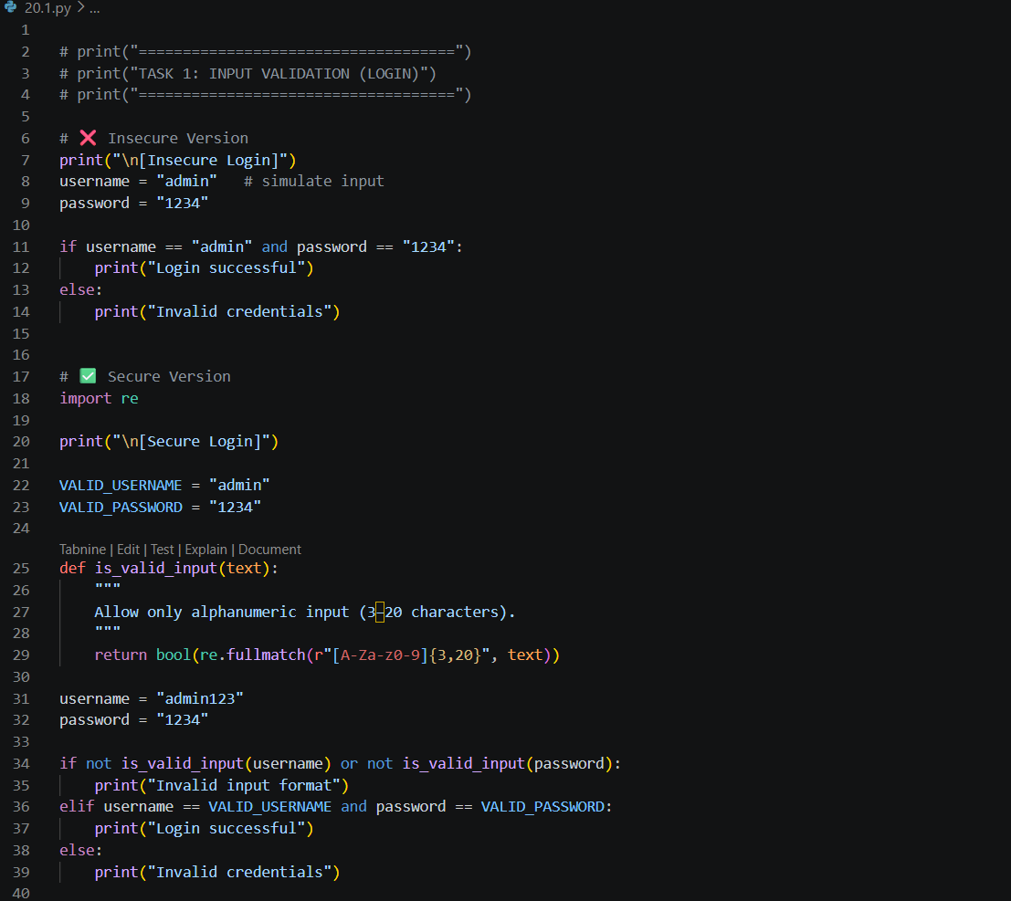
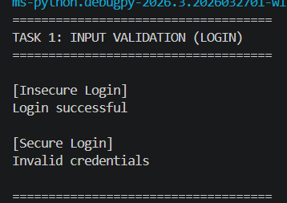

Task 2 – SQL Injection Prevention
Task:
Test an AI-generated script that performs SQL queries on a database.
Instructions:
- Ask AI to generate a Python script using SQLite/MySQL to fetch user details.
- Identify if the code is vulnerable to SQL injection (e.g., using string concatenation in queries).
- Refactor using parameterized queries (prepared statements).
Expected Output:
- A secure database query script resistant to SQL injection.
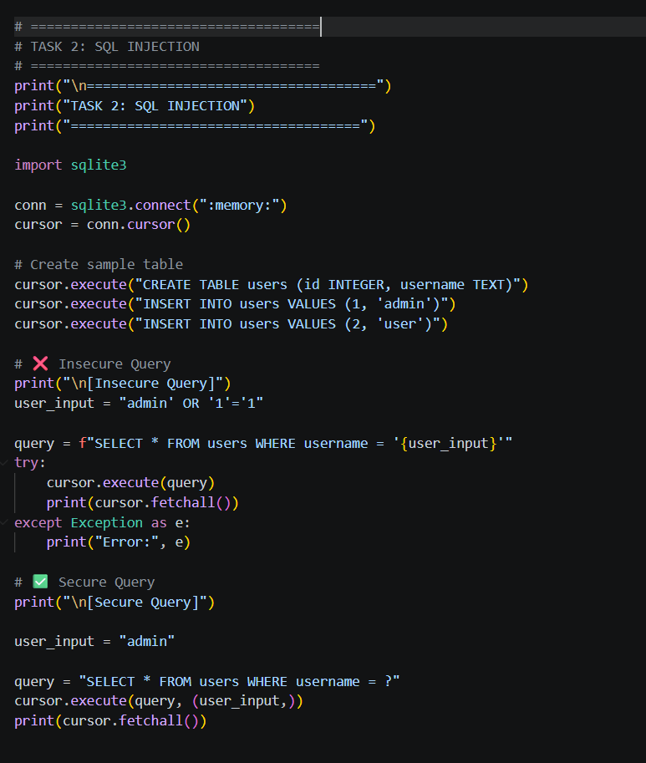
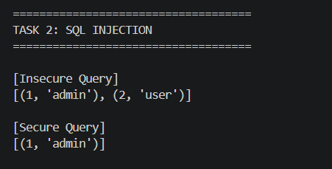

Task 3 – Cross-Site Scripting (XSS) Check
Task:
Evaluate an AI-generated HTML form with JavaScript for XSS vulnerabilities.
Instructions:
- Ask AI to generate a feedback form with JavaScript-based output.
- Test whether untrusted inputs are directly rendered without escaping.
- Implement secure measures (e.g., escaping HTML entities, using CSP).
Expected Output:
- A secure form that prevents XSS attacks.
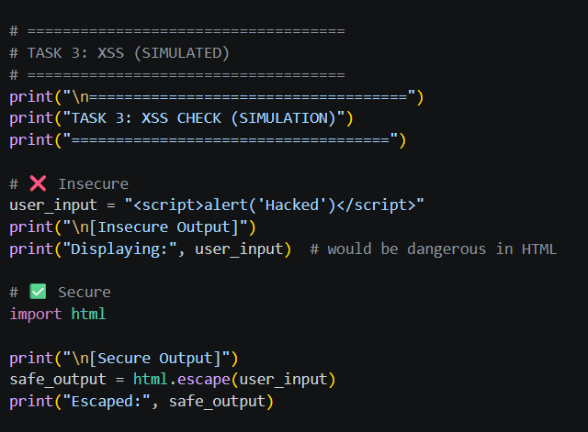
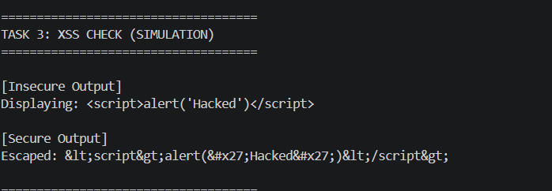

Task 4 – Real-Time Application: Security Audit of AI-Generated Code
Scenario:
Students pick an AI-generated project snippet (e.g., login form, API integration, or file upload).
Instructions:
- Perform a security audit to detect possible vulnerabilities.
- Prompt AI to suggest secure coding practices to fix issues.
- Compare insecure vs secure versions side by side.
Expected Output:
- A security-audited code snippet with documented vulnerabilities and fixes.

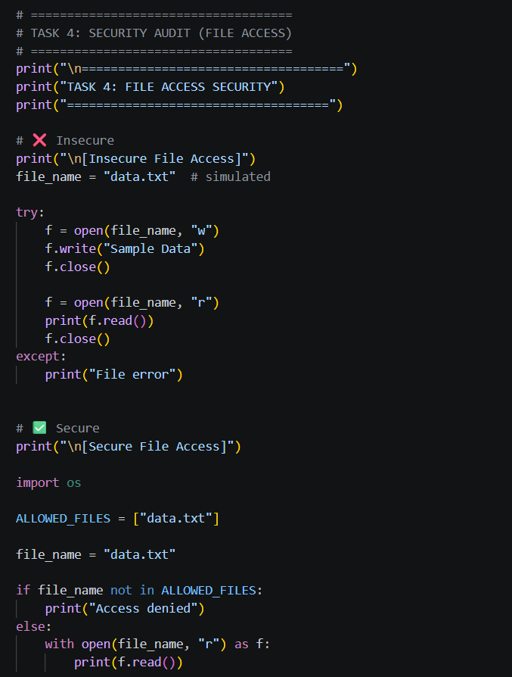
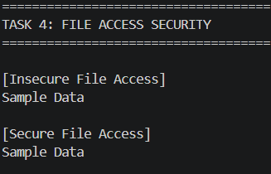

Task 5 – Insecure Data Serialization Check
Task:
Evaluate AI-generated code that uses pickle for saving user data.
Instructions:
- Ask AI to generate a script using pickle.load().
- Explain why untrusted pickle data is dangerous.
- Replace with safer formats like JSON.
Expected Output:
- Secure serialization code using JSON instead of pickle.
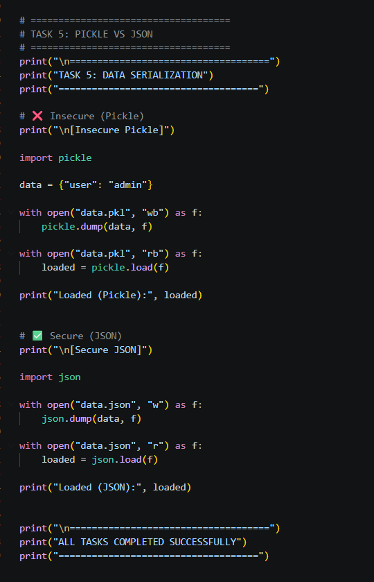
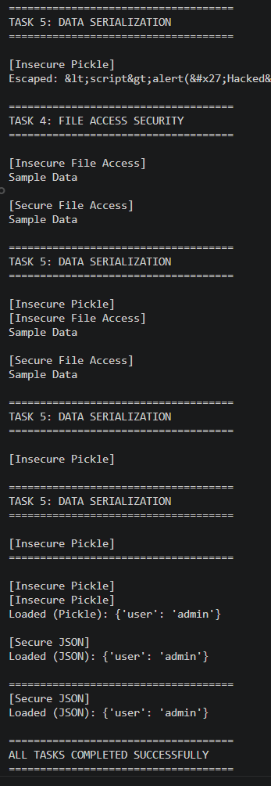

Note: Report should be submitted as a word document for all tasks in a single document with prompts, comments & code explanation, and output and if required, screenshots.

